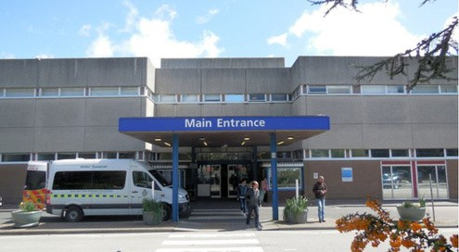
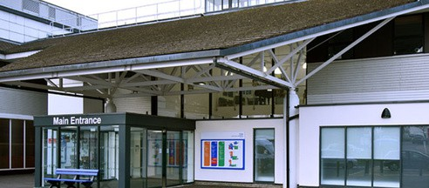


Health Care Passport

For those with ongoing healthcare needs
It tells you:
Things you must know about me
Things that are important to me
My likes and dislikes
My name is
My Photo

Please Read
To all staff:- please check with the person or supporter that the information is accurate. Sign page 9
Mental Capacity Act 2005
If I am assessed as lacking the capacity to consent to my treatment, the following people must be involved in any decisions made in my best interests
Name
Relationship
Contact details
If I attend or go to the hospital, this passport needs to go with me and stay with me or with my hospital notes
This passport belongs to me, please return it to me when I go home
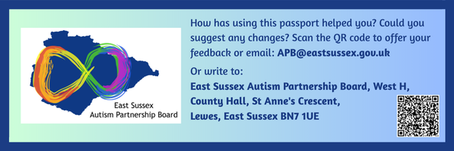

This page is intentionally blank

Things you must know about me


Hello, my name is:

I like to be known as:

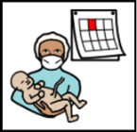
Date of birth:


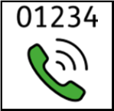

Address:

Phone number:

Ethnicity/ religion:

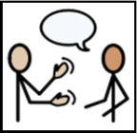
How to communicate with me:

How I communicate with you:

How I would like to be contacted (e.g. phone, text, easy read letter):

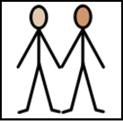
Name, address and tel. number of next of kin:

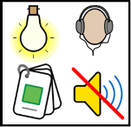
What reasonable adjustments do I need?

Things you must know about me
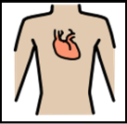
Allergies:

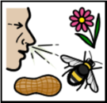
Heart problems:

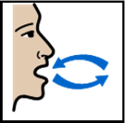
Breathing problems:

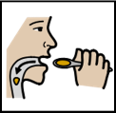
Risk of choking or Dysphagia (eating, drinking & swallowing difficulties):


Name of GP:

Phone number:
Address:
Other services/ professionals involved in my care:


What makes me feel anxious, upset or worried? (e.g. the dark, noise or crowds) How do I show this?


What helps me when I feel like this?

Things you must know about me

Current medication:

How I take my medication (e.g. self-medicates or needs support, on food, in liquid form, by injection.):

What is the best way to tell me, or someone that supports me, about my medication when I go home?

My medical history:

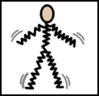
Epilepsy information (e.g. seizure pattern, what a normal seizure looks like for me, my normal recovery time and management plan – attach epilepsy care plan):


Medical interventions (e.g. how to take my blood, give
injections, blood pressure etc.)

Things that are important to me
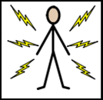
How you know I am in pain: (e.g. posture, skin colour, sounds etc.)
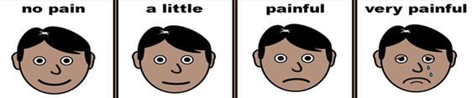

This pain chart can be useful for patients when they are not able to speak, to point to the picture that represents how they feel.

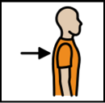
How I move around: (e.g. postural care, walking aids, transfers, hoisting)
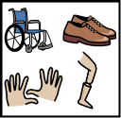

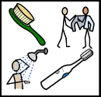
My personal care: (e.g. for dressing, washing, what support I need):

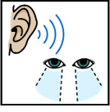
My seeing and hearing: (e.g. problems with sight or hearing)

Things that are important to me
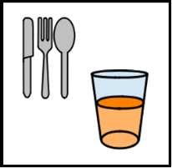
How I eat & drink: (e.g. drink small amounts, thickened fluids, dietary requirements, support needs)

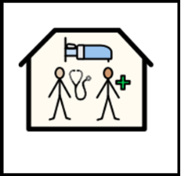
How I keep safe: (e.g. side room, low bed, bed rails, seizure monitoring and support from familiar staff)

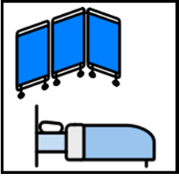


How I use the toilet: (e.g. continence aids, help to get to the toilet, normal bowel and bladder management for me)

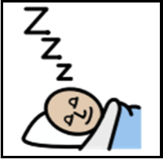
How I sleep: (e.g. my sleep pattern and bedtime routine)

My Likes and Dislikes
Likes: for example – what makes me happy, things I like to do and are important to me (e.g. hobbies, watching TV, reading music, routines)

Dislikes: e.g. don’t shout, food I don’t like, physical touch, needles (needles can’t be avoided but reasonable adjustments can be made to reduce distress)

Things I like (please do this.)

Things I don’t like (please don’t do this.)

When I come to hospital or any appointment, I like to bring in some of my favourite things, e.g. blanket, photos, sensory objects.

This page is intentionally blank

Notes:
Important information or things to talk about to help build relationships with me or help take my mind off things (distraction)

This page is intentionally blank

Health Care Review
Name:
Year:
It is important that information is accurate and up to date, please review regularly if needs
change regularly. It is good practice to review and re-date yearly if needs remain the same.
Please tick when information has been checked or updated | Jan | Feb | Mar | Apr | May | Jun | Jul | Aug | Sep | Oct | Nov | Dec
Things you must know about me
Things that are important to me
My likes and dislikes
Anything else

Please briefly summarise any changes here
January
February
March
April
May
June
July
August
September
October
November
December
Hospital staff: sign and date, if supporter has confirmed information is accurate
Sign | Date | Sign | Date
About me is based on original work by Gloucester Partnership NHS Trust and the South West London Hospital Access to Acute Group. Acknowledgement to Kay Hitch Way, Metropolitan for allowing replication of Review Sheet. Adapted by North West Anglia – consent gained to adapt Dec 2021 for ESHT All Images/Resources copyright © LYPFT Adapted/Updated Jan 2022 ESHT Updated by East Sussex County Council with permission July 2025

At a Glance Sheet
Please list five key points that, at a glance, staff need to know about me when supporting me in hospital or medical care (use clear large font or writing)
(Staff - please photocopy with permission and display this sheet visibly)
1
2
3
4
5
What I am like when I am well

